Testing Screenshots
Submission Analytics & Underwriting Assistant

Scenario-1: Data (pdf) upload, extraction and load into MariaDB (pdf_submission) table.
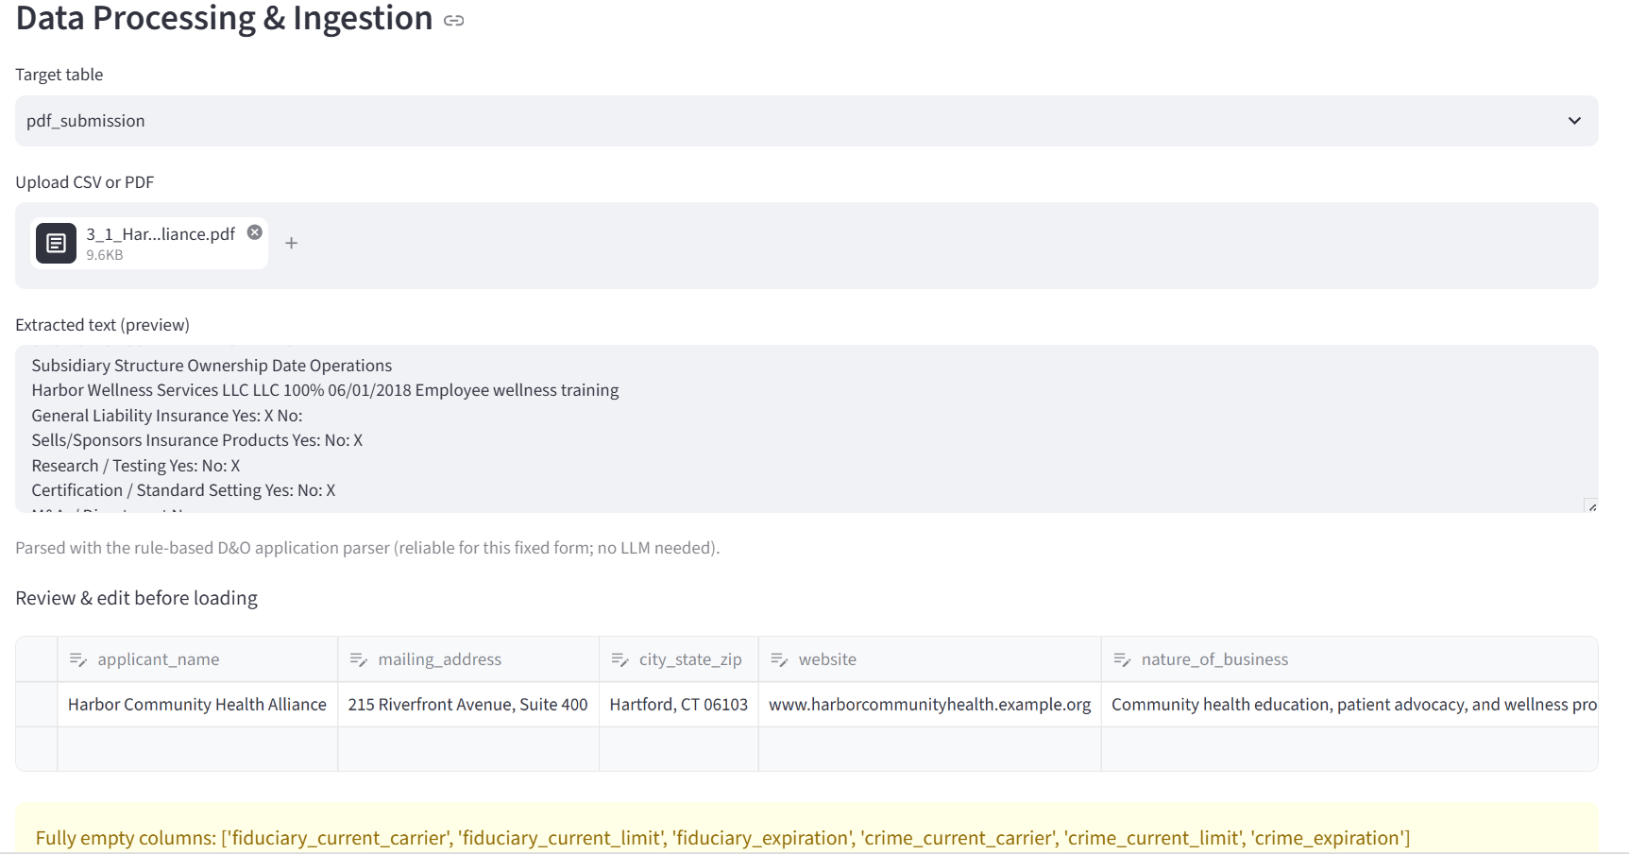
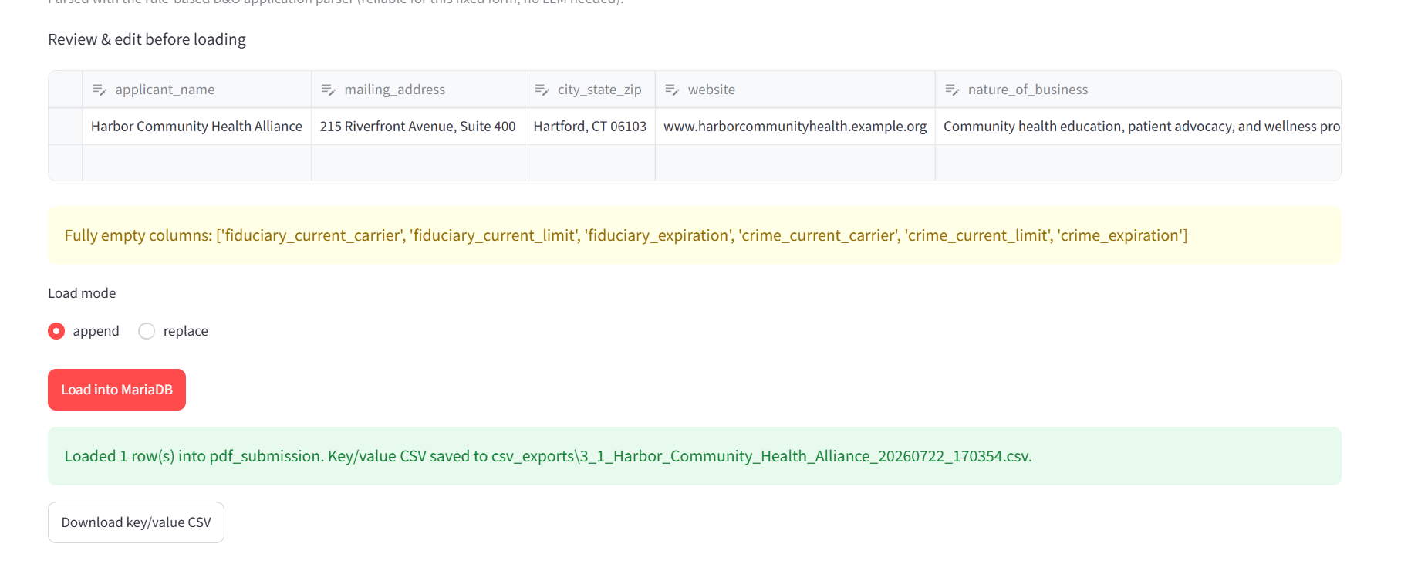
Validation from MariaDB Database if Ingestion was Successful:
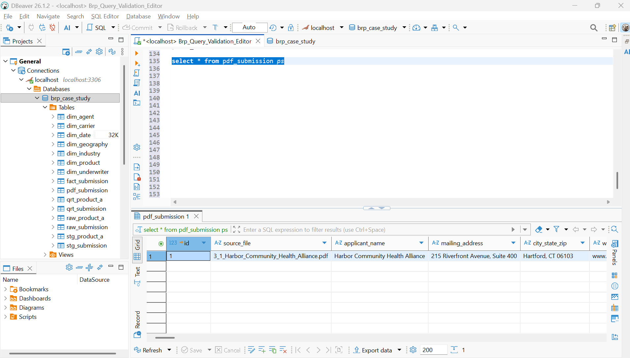

Scenario-2: Data Insights Tab:
- Dropdown to select data table working?

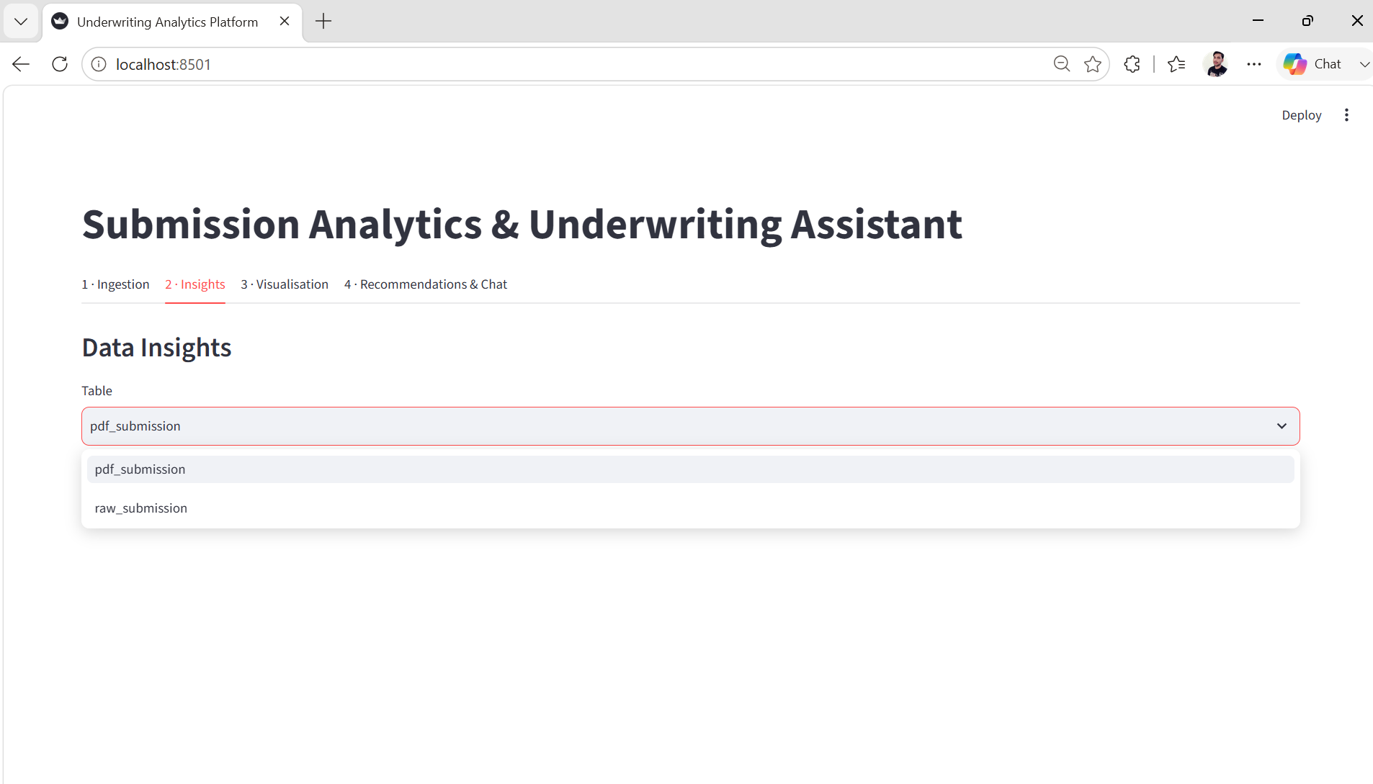

- Does “Profile Table” button works and gives Insights about data?

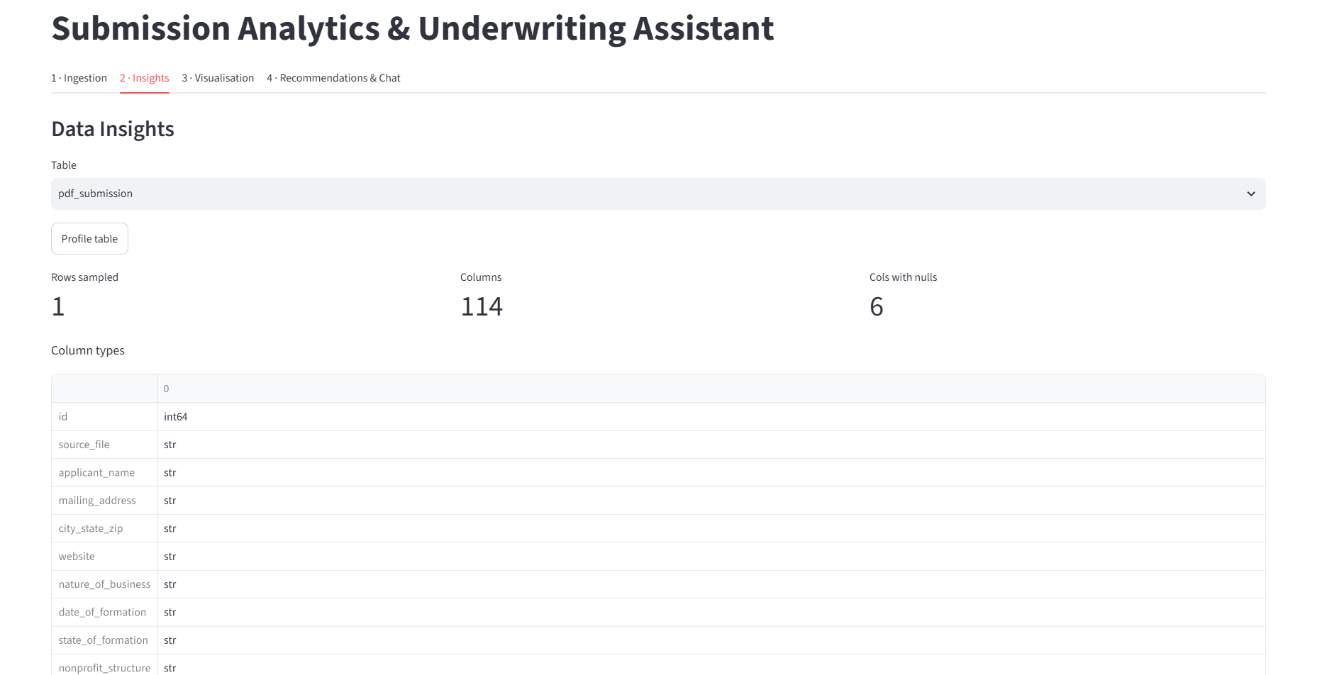

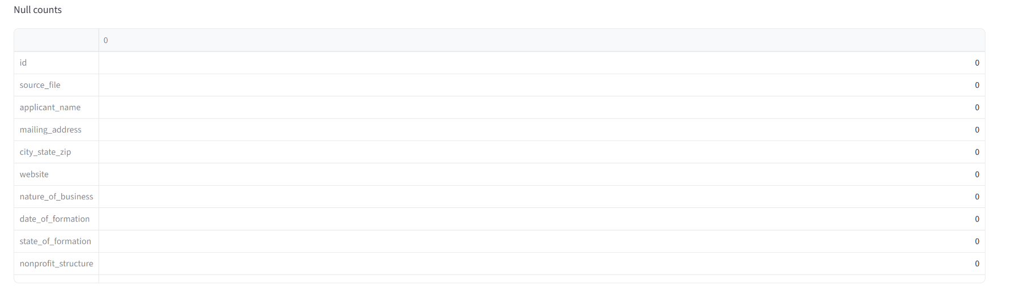
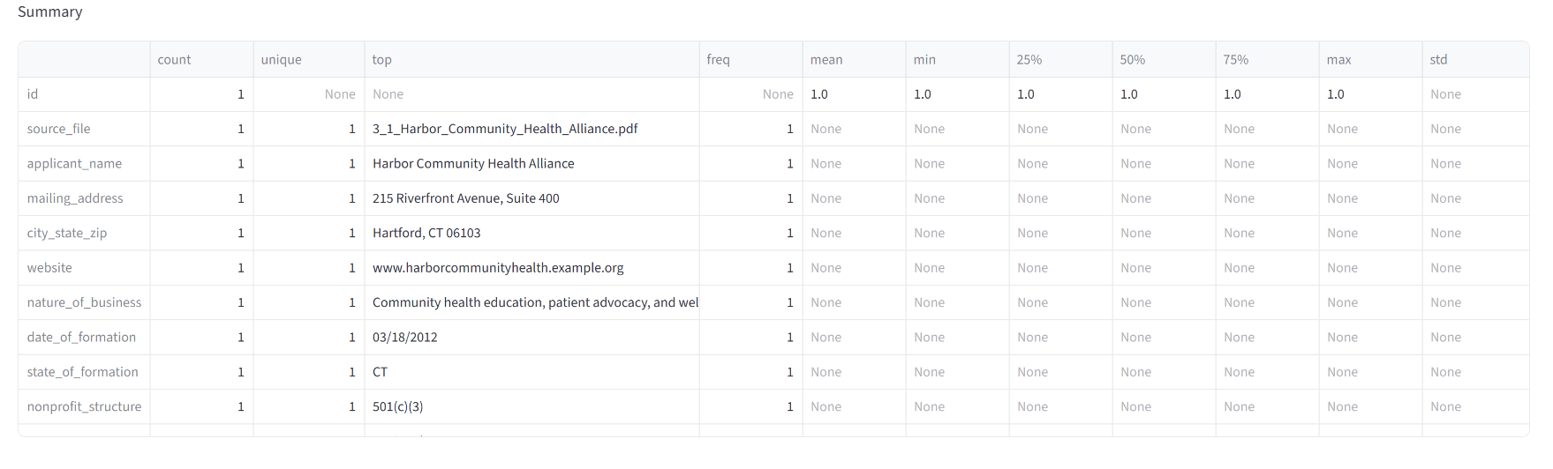

Scenario-3: Visualization tab works?

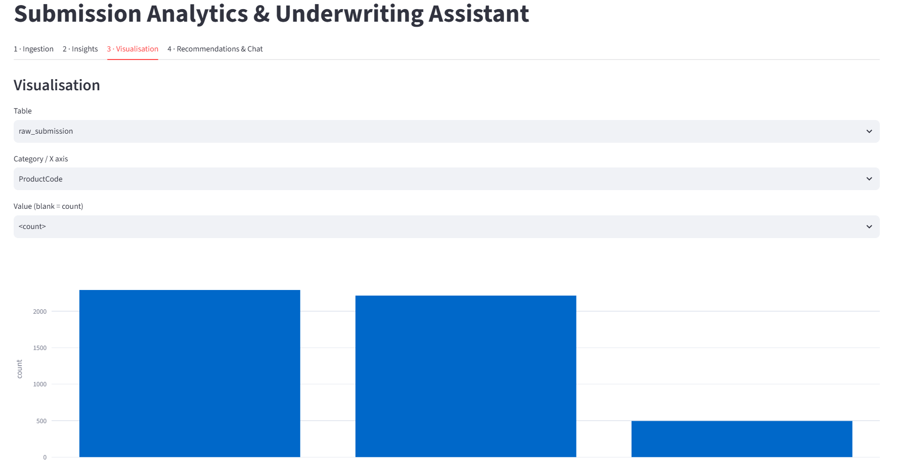

- Does the data table dropdown work?

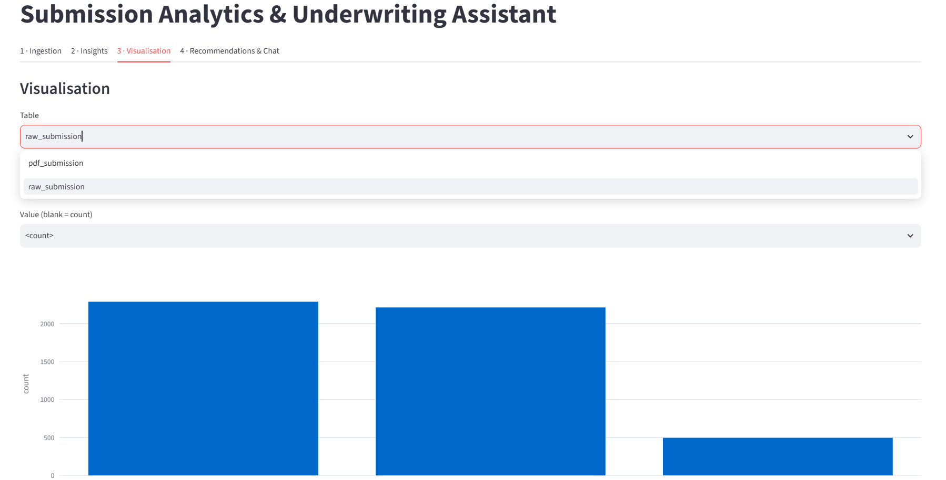

- Does the category (X-axis) work?

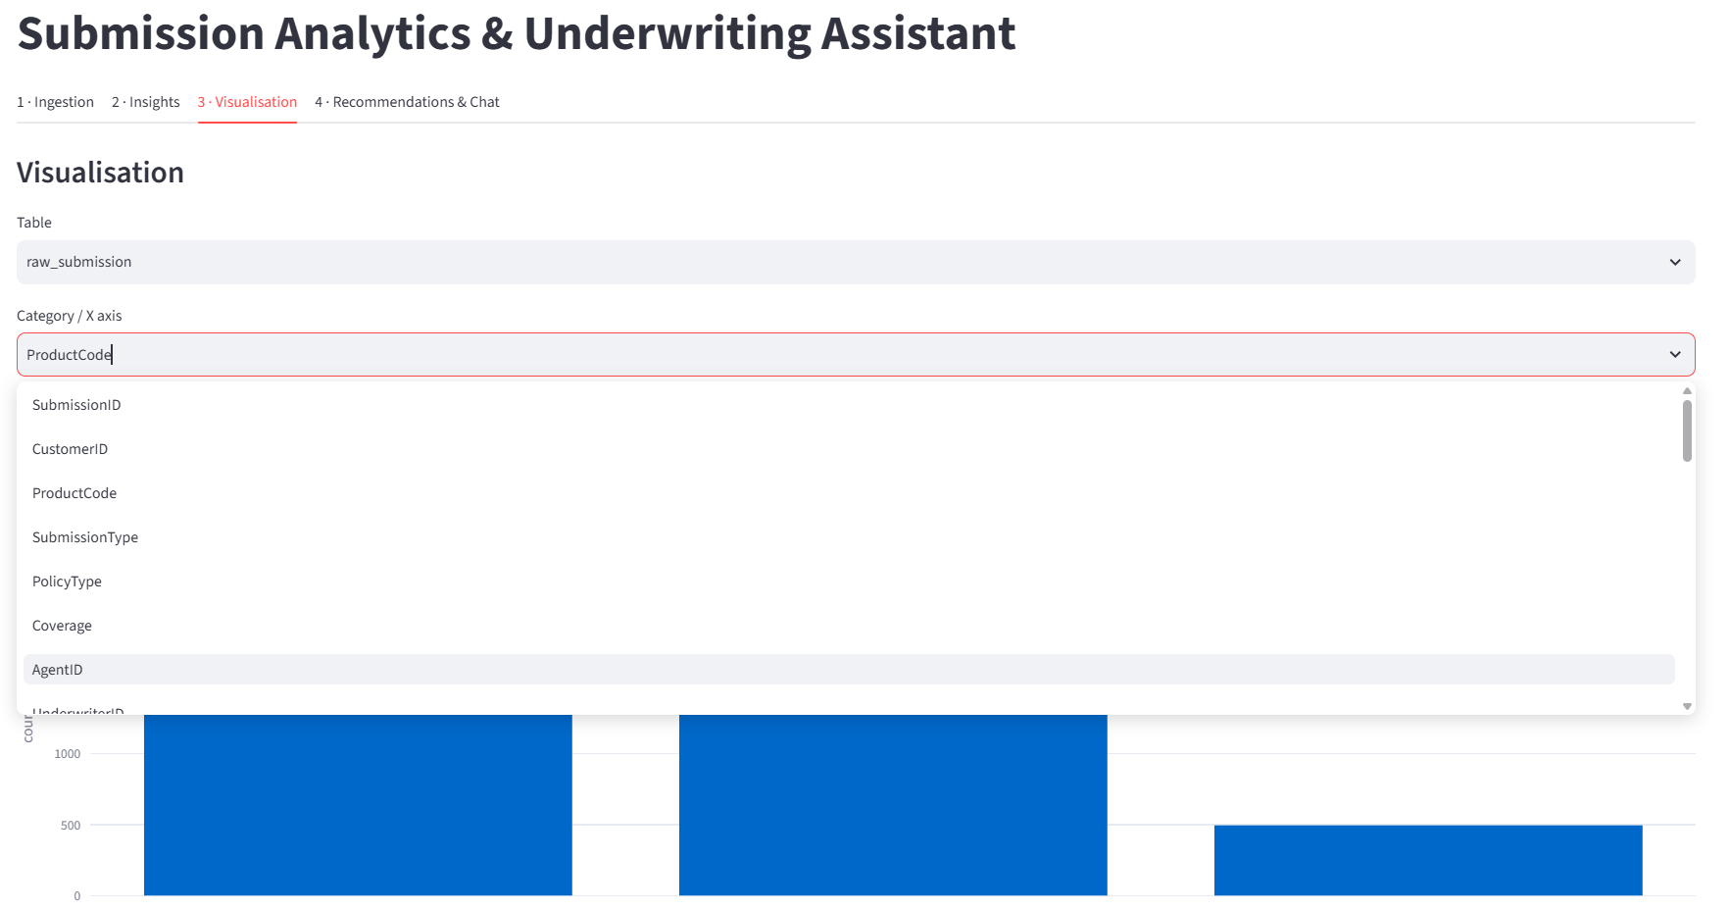

- Can you see the ProductCode and count while hover over the cursor on bar?

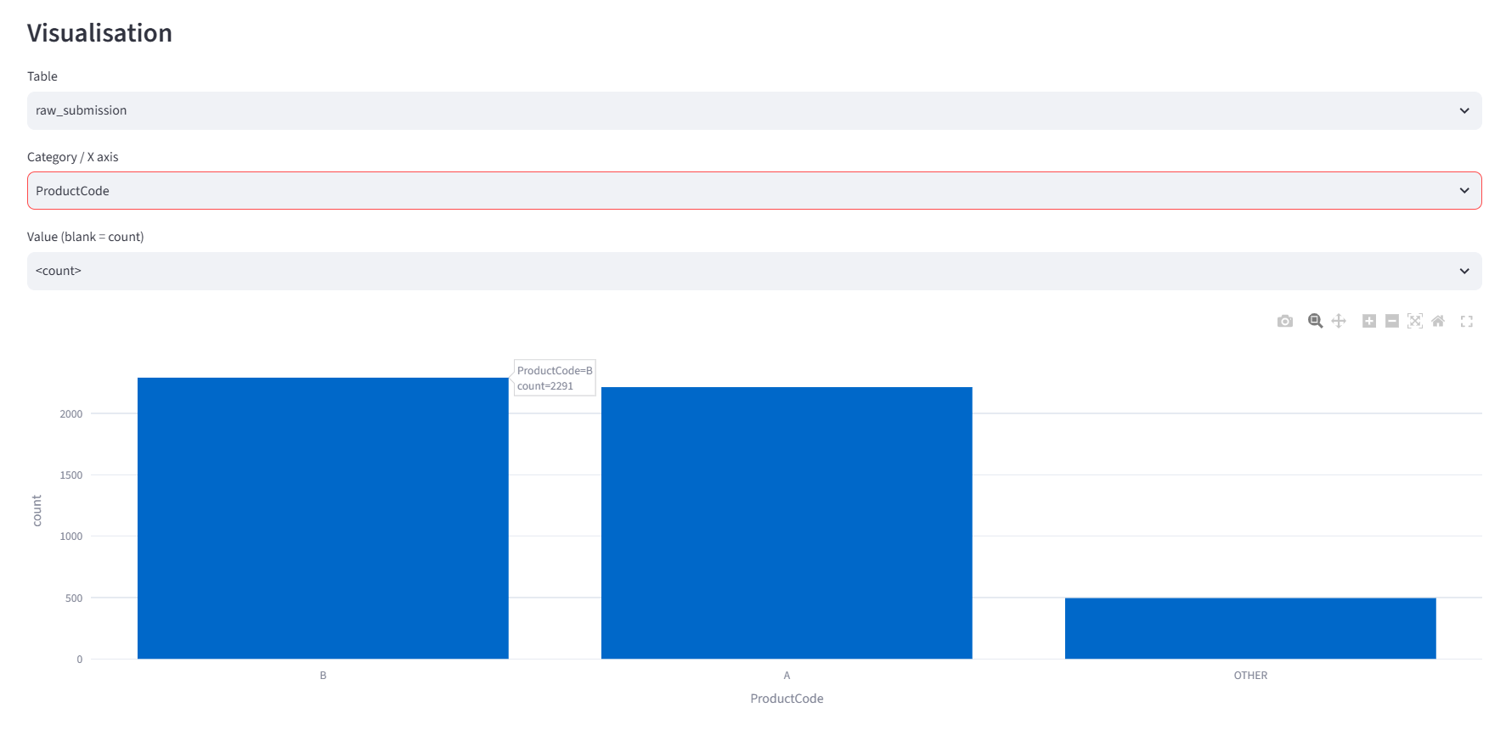

Scenario-4: Does the Recommendations & Chat tab works?

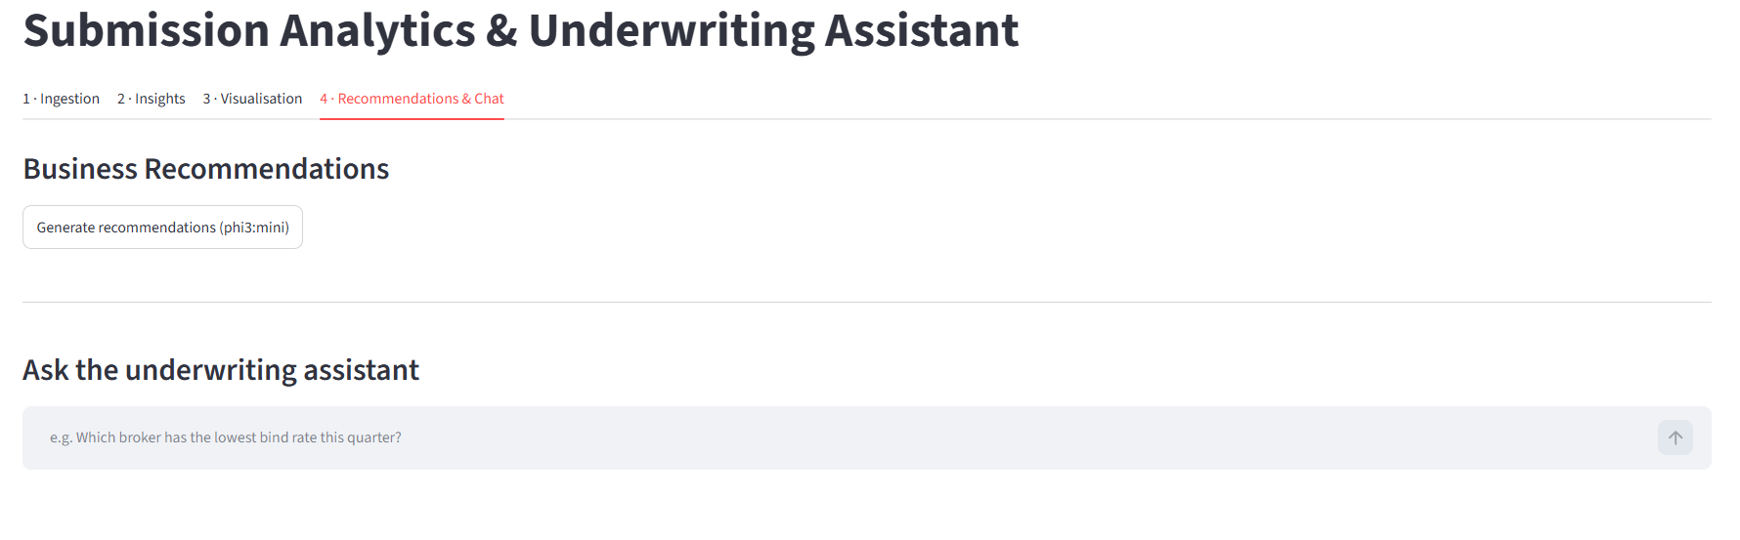
- Does the “Generate Recommendations” button work?

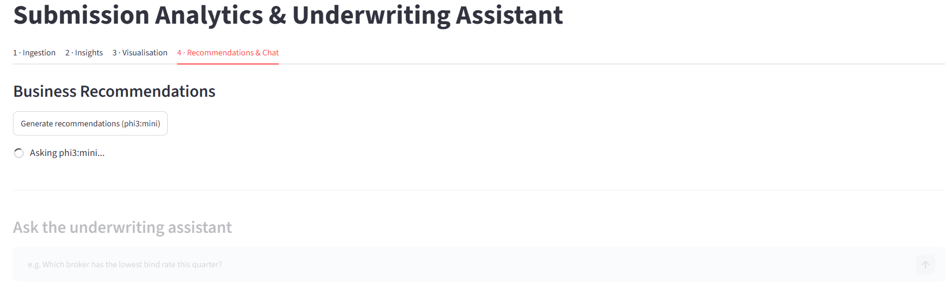

- Does it give recommendations?

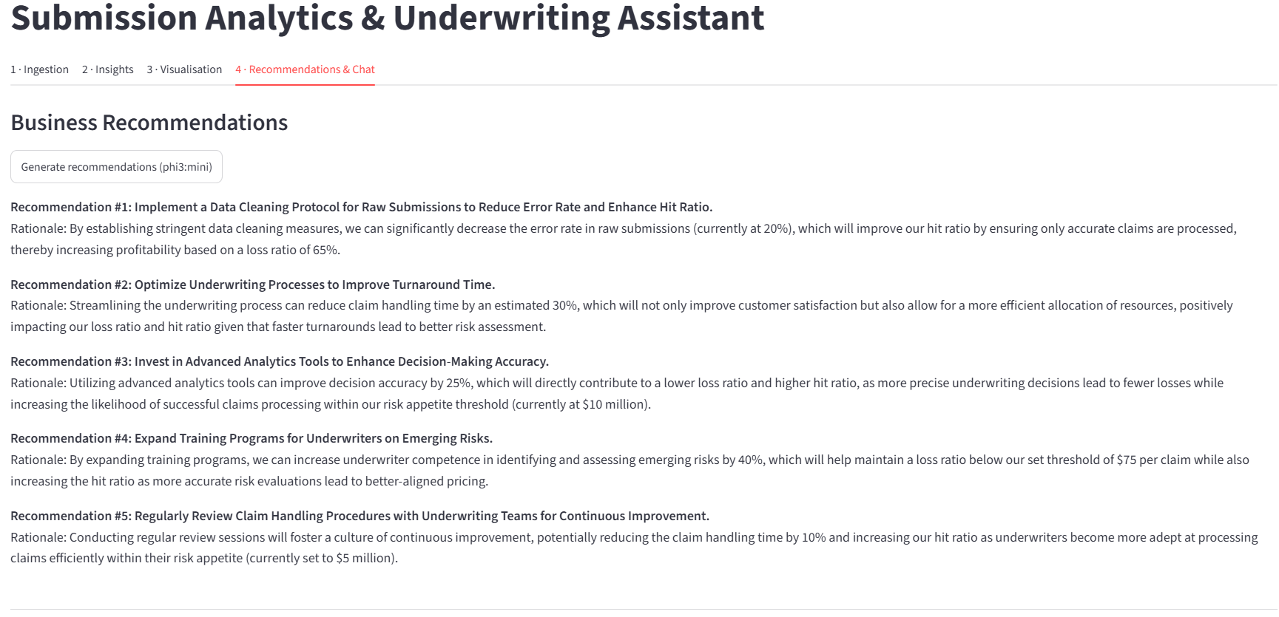

- Does the “Ask the underwriting assistant” button work?

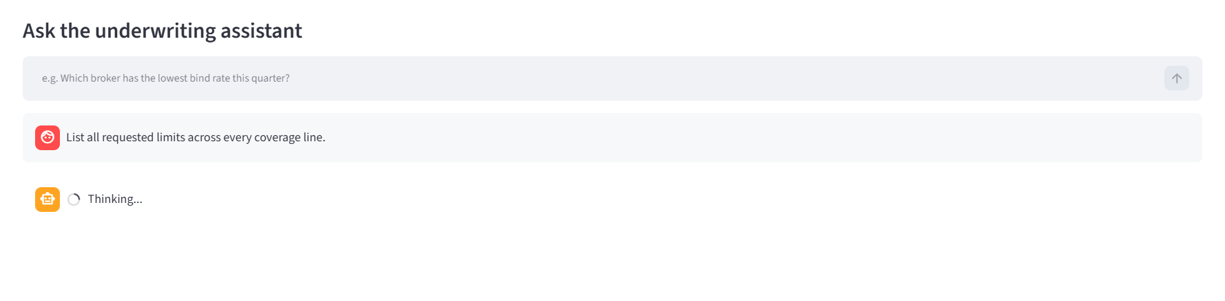

- Dose it response like a meaningful response?

